Triangle Similarity

Definition
# Source: AI Source: Provided by: [Data Path: Persons Table -> ID Column: 1, Name_En Column: Motasem Essam] -> From: [ChatGPT] on [7/25/2026]
Triangle Similarity is a geometric relationship in which two triangles have the same shape but not necessarily the same size.
Two triangles are similar if their:
- Corresponding angles are equal.
- Corresponding side lengths are proportional.
The symbol for similarity is:
$$\boxed{∼}$$
Therefore:
$$\boxed{△ABC∼△DEF}$$
means that triangle $ABC$is similar to triangle $DEF$.
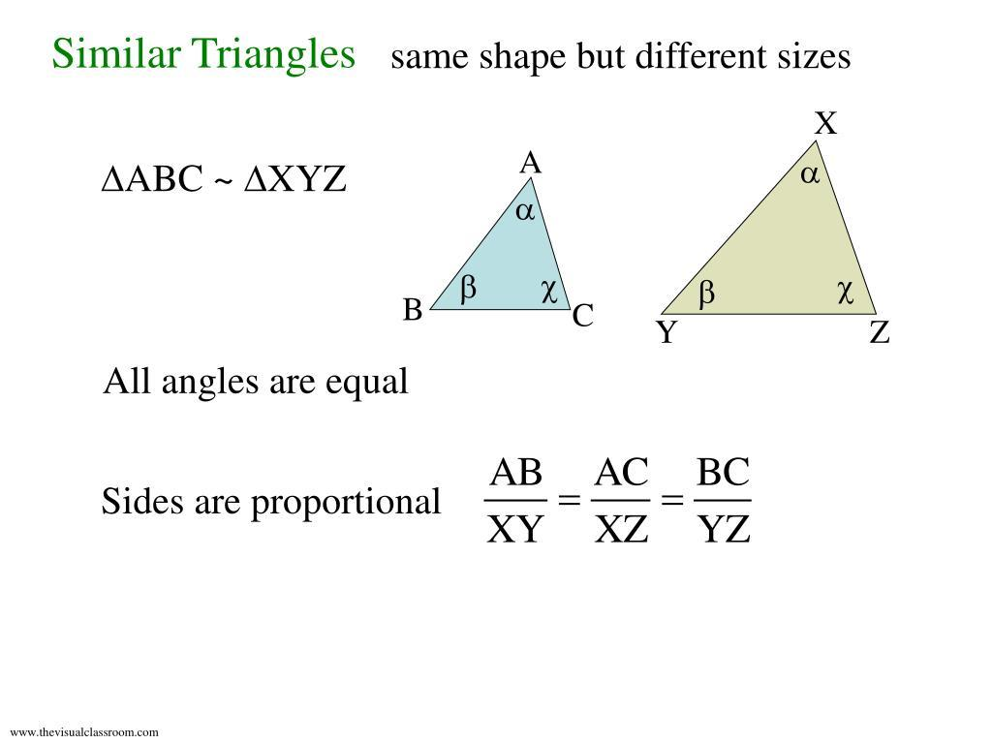
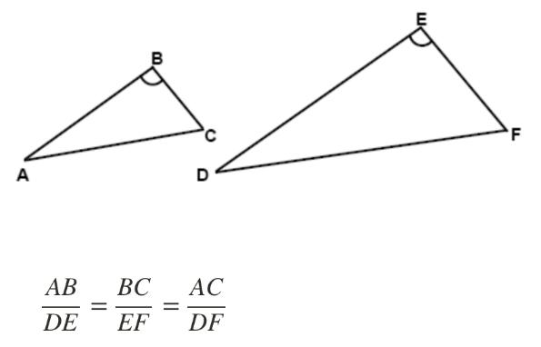
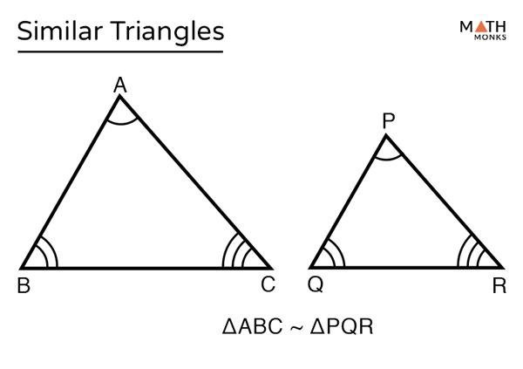
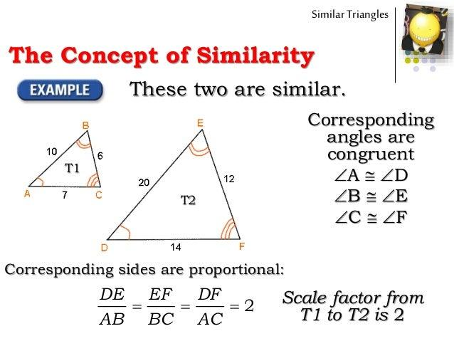
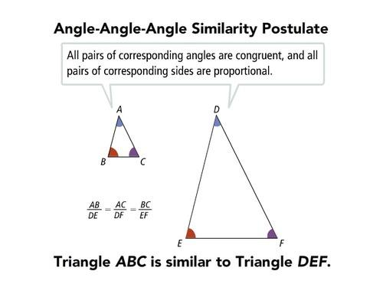

Purpose
# Source: AI Source: Provided by: [Data Path: Persons Table -> ID Column: 1, Name_En Column: Motasem Essam] -> From: [ChatGPT] on [7/25/2026]
Triangle similarity is used to:
- Compare triangles of different sizes.
- Calculate unknown side lengths.
- Calculate unknown angles.
- Establish proportional relationships.
- Solve indirect measurement problems.
- Determine heights and distances.
- Analyze geometric figures.
- Support trigonometry.
- Solve engineering and surveying problems.

Fundamental Idea
# Source: AI Source: Provided by: [Data Path: Persons Table -> ID Column: 1, Name_En Column: Motasem Essam] -> From: [ChatGPT] on [7/25/2026]
Two triangles are similar when they have the same shape.
For:
$$△ABC∼△DEF$$
the correspondence is:
$$\boxed{A↔D} \\ \boxed{B↔E} \\ \boxed{C↔F}$$
Therefore, corresponding angles are equal:
$$\boxed{∠A=∠D} \\ \boxed{∠B=∠E} \\ \boxed{∠C=∠F}$$
and corresponding sides are proportional:
$$\boxed{\frac{AB}{DE}=\frac{BC}{EF}=\frac{AC}{DF}}$$

Similarity Symbol
# Source: AI Source: Provided by: [Data Path: Persons Table -> ID Column: 1, Name_En Column: Motasem Essam] -> From: [ChatGPT] on [7/25/2026]
The symbol:
$$\boxed{∼}$$
means is similar to.
For example:
$$\boxed{△ABC∼△DEF}$$
This is different from the congruence symbol:
$$\boxed{≅}$$
which means the figures have the same size and shape.

Corresponding Parts
# Source: AI Source: Provided by: [Data Path: Persons Table -> ID Column: 1, Name_En Column: Motasem Essam] -> From: [ChatGPT] on [7/25/2026]
When two triangles are similar, their corresponding parts occupy the same relative positions.
For:
$$△ABC∼△DEF$$
Corresponding Vertices
$$A↔D \\ B↔E \\ C↔F$$
Corresponding Sides
$$AB↔DE \\ BC↔EF \\ AC↔DF$$
Corresponding Angles
$$∠A↔∠D \\ ∠B↔∠E \\ ∠C↔∠F$$
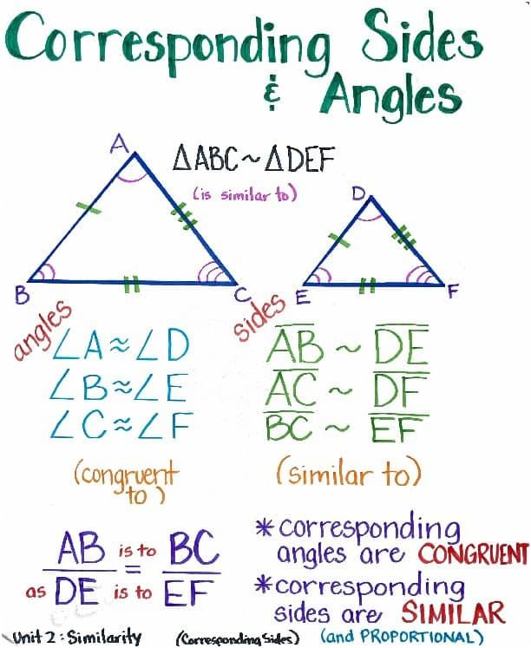
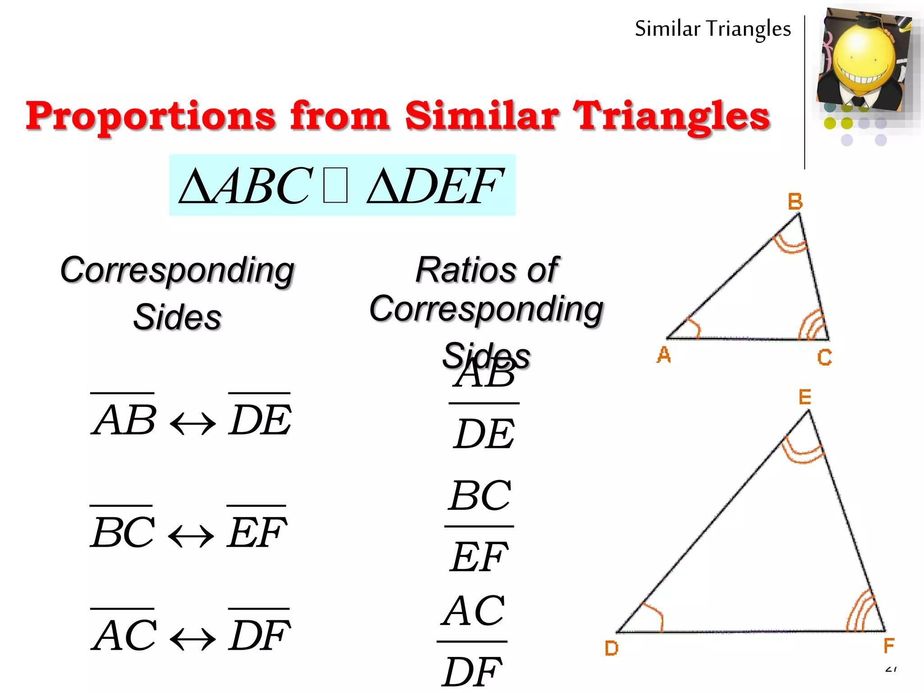
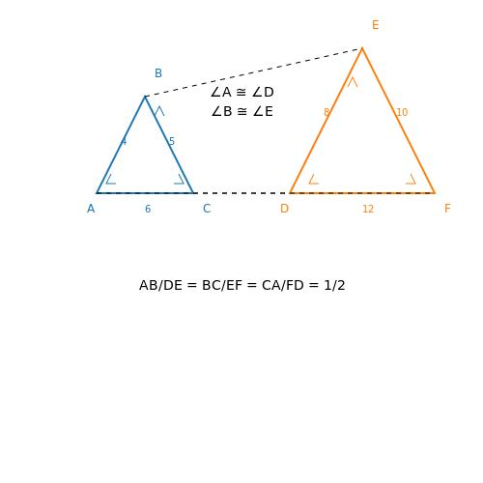
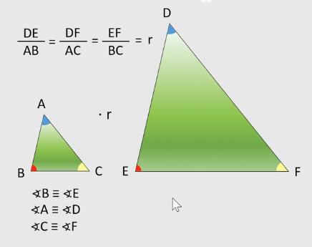
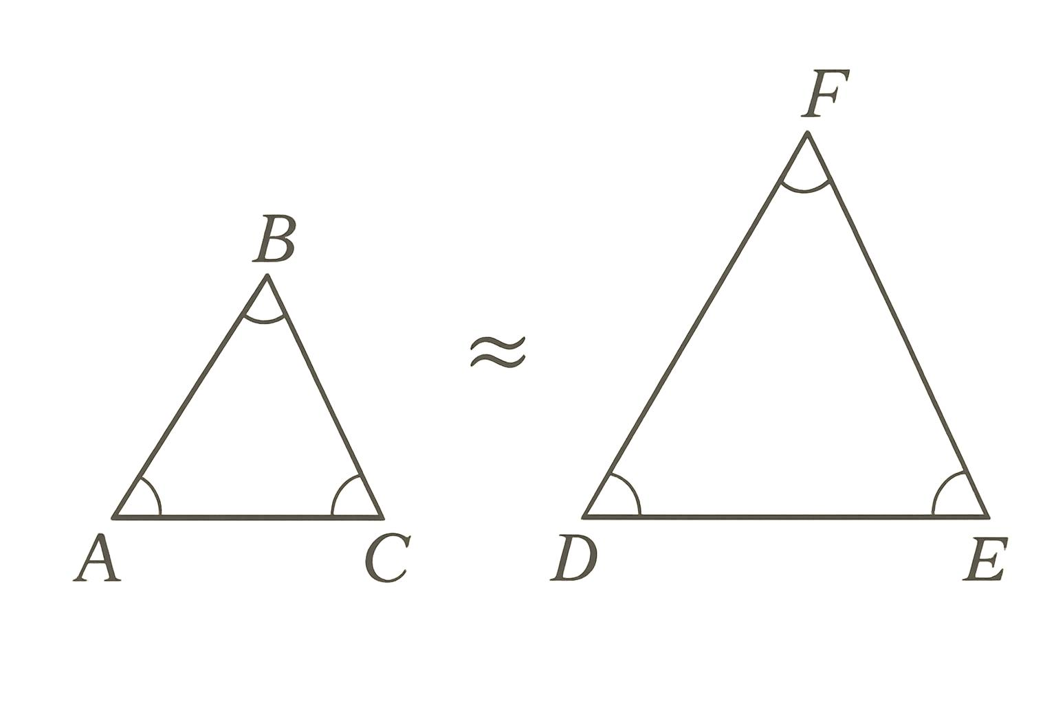

Scale Factor
# Source: AI Source: Provided by: [Data Path: Persons Table -> ID Column: 1, Name_En Column: Motasem Essam] -> From: [ChatGPT] on [7/25/2026]
The scale factor describes how much larger or smaller one similar triangle is compared with another.
If:
$$△ABC∼△DEF$$
and:
$$\frac{DE}{AB}=k$$
then $k$is the scale factor from triangle $ABC$to triangle $DEF$.
$$\boxed{k=\frac{\text{corresponding side in new triangle}}{\text{corresponding side in original triangle}}}$$

Example of Scale Factor
# Source: AI Source: Provided by: [Data Path: Persons Table -> ID Column: 1, Name_En Column: Motasem Essam] -> From: [ChatGPT] on [7/25/2026]
Suppose one triangle has sides:
$$3, 4, 5$$
and another has:
$$6, 8, 10$$
Then:
$$\frac{6}{3}=2 \\ \frac{8}{4}=2 \\ \frac{10}{5}=2$$
Therefore:
$$\boxed{k=2}$$
The second triangle is twice as large in every linear dimension.
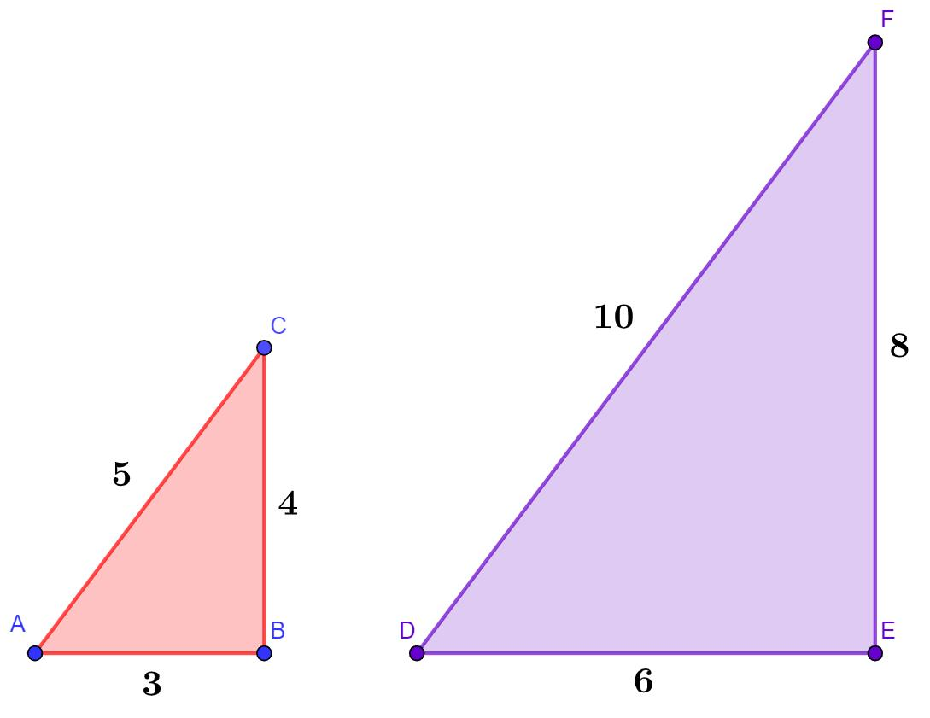
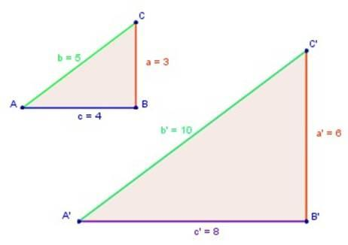
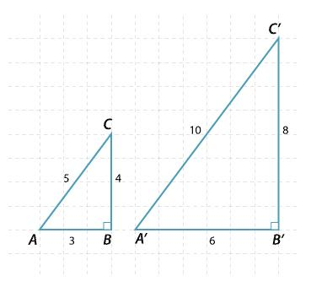
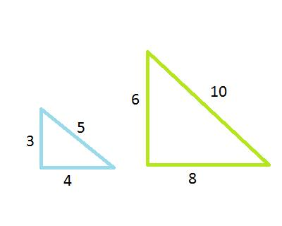
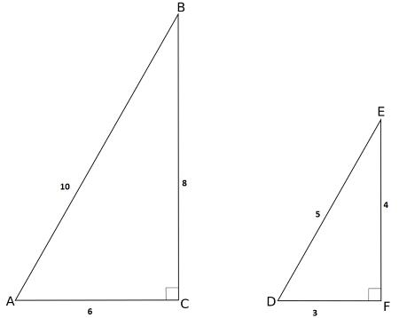
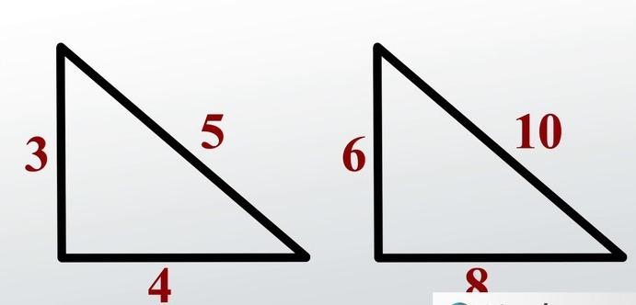

Types of Triangle Similarity
# Source: AI Source: Provided by: [Data Path: Persons Table -> ID Column: 1, Name_En Column: Motasem Essam] -> From: [ChatGPT] on [7/25/2026]
There are three major criteria for proving that two triangles are similar:
- AA
- SAS
- SSS

1. AA — Angle-Angle Similarity
# Source: AI Source: Provided by: [Data Path: Persons Table -> ID Column: 1, Name_En Column: Motasem Essam] -> From: [ChatGPT] on [7/25/2026]
AA means Angle-Angle.
If two corresponding angles of one triangle are equal to two corresponding angles of another triangle, the triangles are similar.
For example:
$$∠A=∠D$$
and:
$$∠B=∠E$$
then:
$$\boxed{△ABC∼△DEF}$$
by AA similarity.
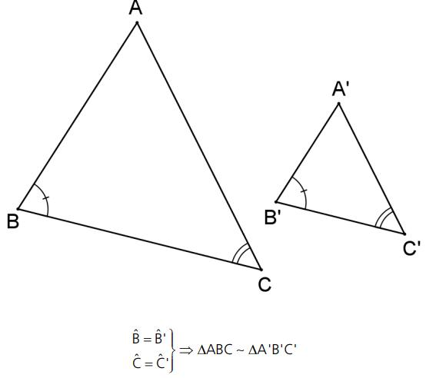
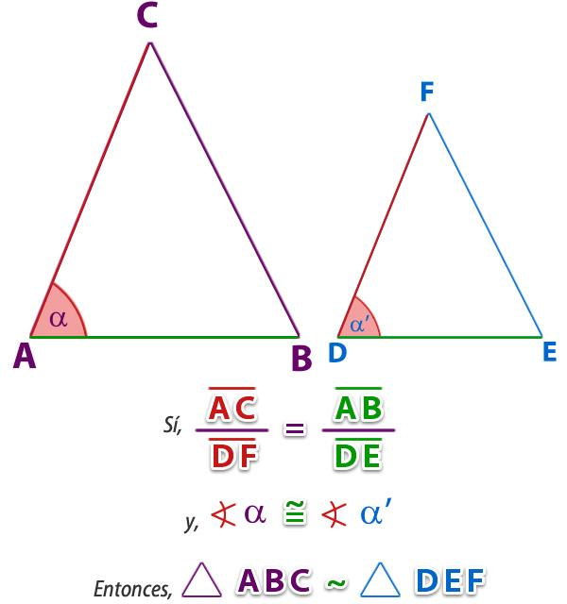
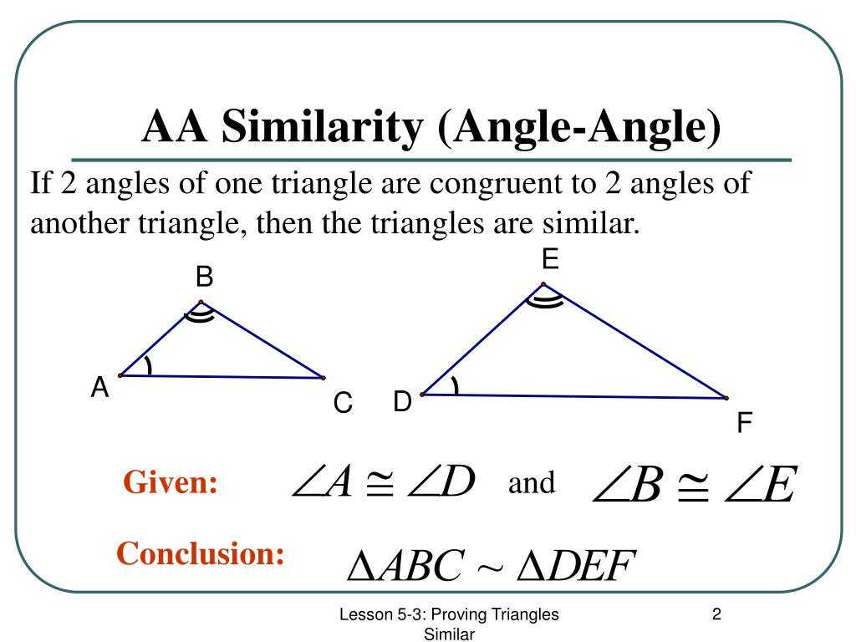
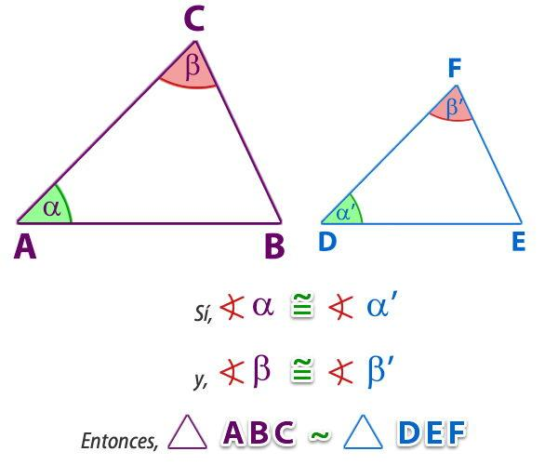
Why are two angles enough?
Because the angles of every triangle add up to:
$${180}^{∘}$$
Therefore, if two angles are equal, the third angles must also be equal.

2. SAS — Side-Angle-Side Similarity
# Source: AI Source: Provided by: [Data Path: Persons Table -> ID Column: 1, Name_En Column: Motasem Essam] -> From: [ChatGPT] on [7/25/2026]
Two triangles are similar by SAS if:
- Two pairs of corresponding sides are proportional.
- The included angles are equal.
For example:
$$\frac{AB}{DE}=\frac{BC}{EF}$$
and:
$$∠B=∠E$$
Therefore:
$$\boxed{△ABC∼△DEF}$$
by SAS similarity.
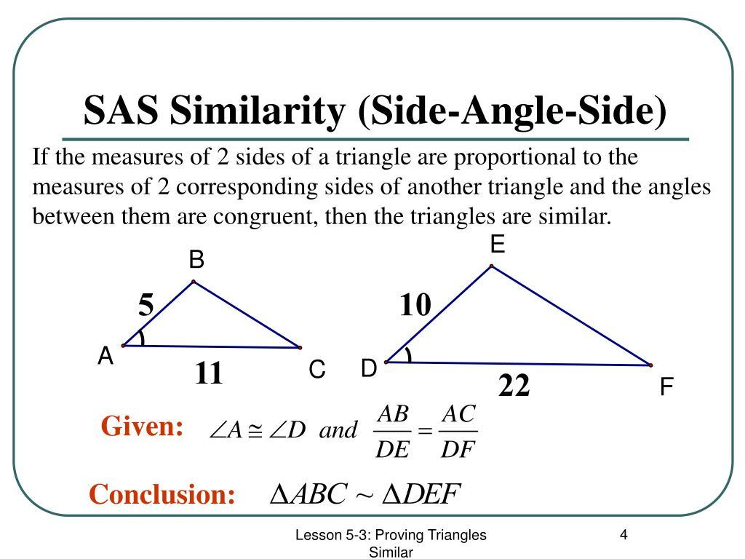
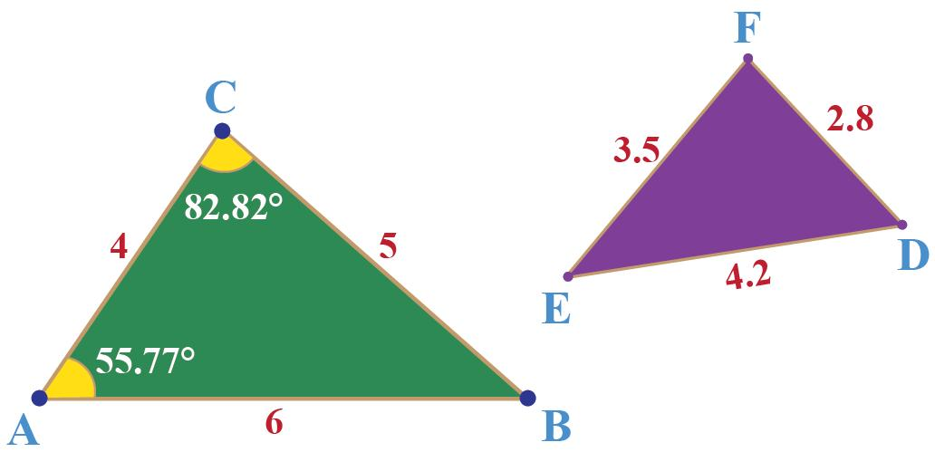
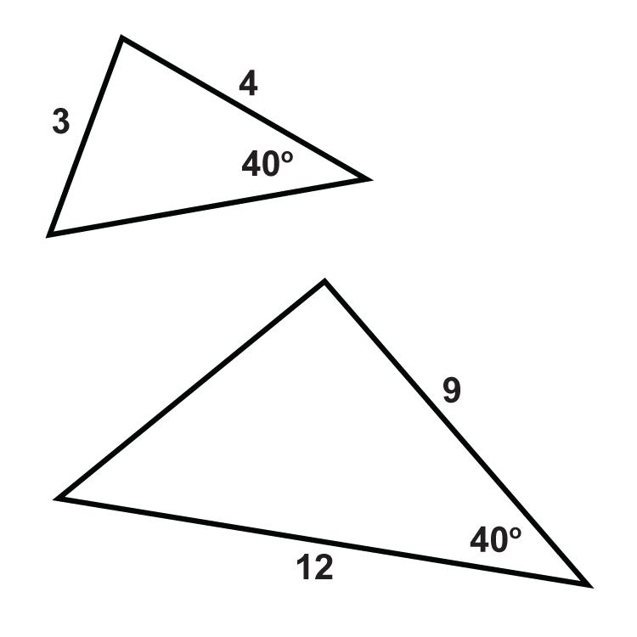
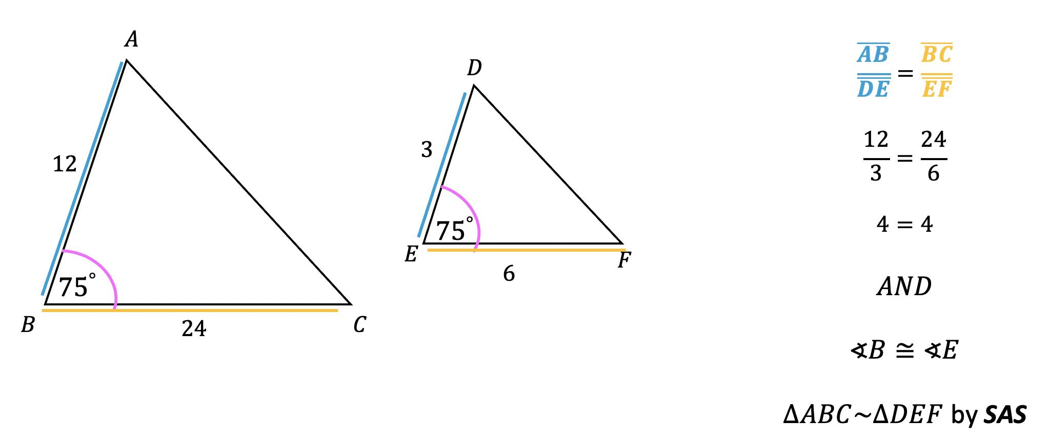
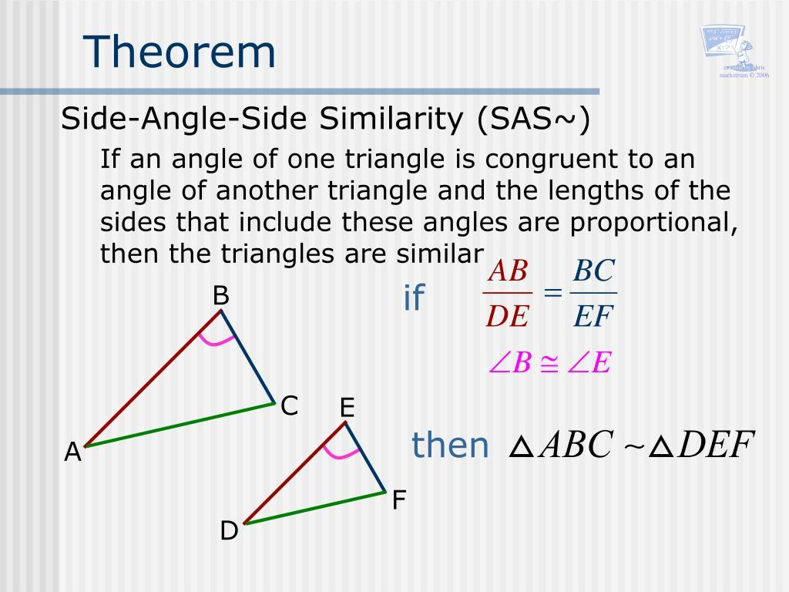

3. SSS — Side-Side-Side Similarity
# Source: AI Source: Provided by: [Data Path: Persons Table -> ID Column: 1, Name_En Column: Motasem Essam] -> From: [ChatGPT] on [7/25/2026]
Two triangles are similar by SSS if all three pairs of corresponding sides are proportional.
For example:
$$\frac{AB}{DE}=\frac{BC}{EF}=\frac{AC}{DF}$$
Therefore:
$$\boxed{△ABC∼△DEF}$$
by SSS similarity.
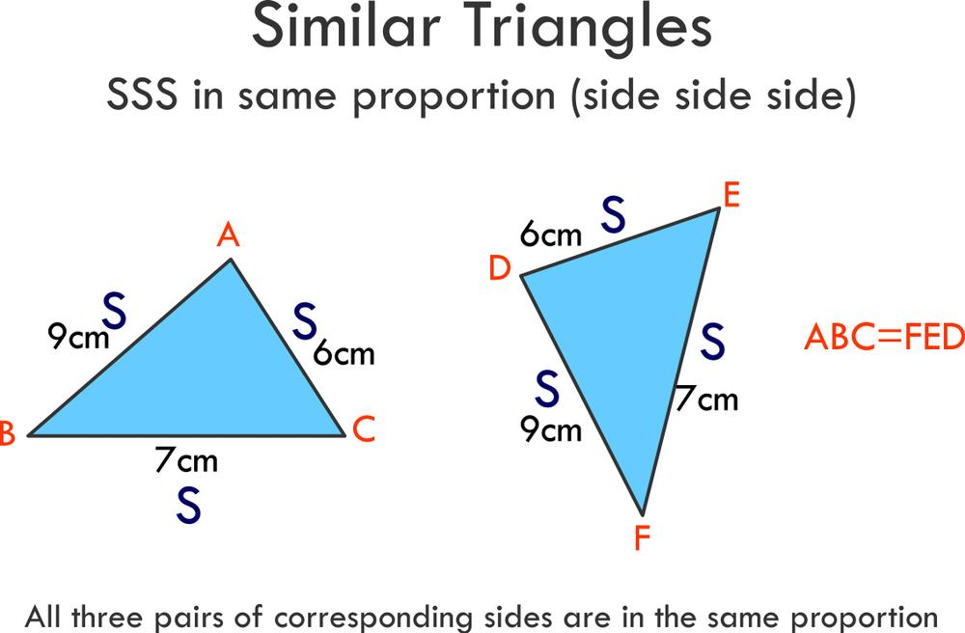
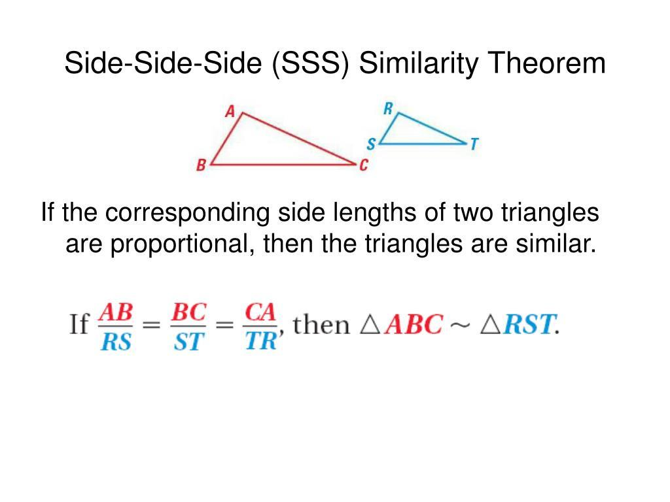
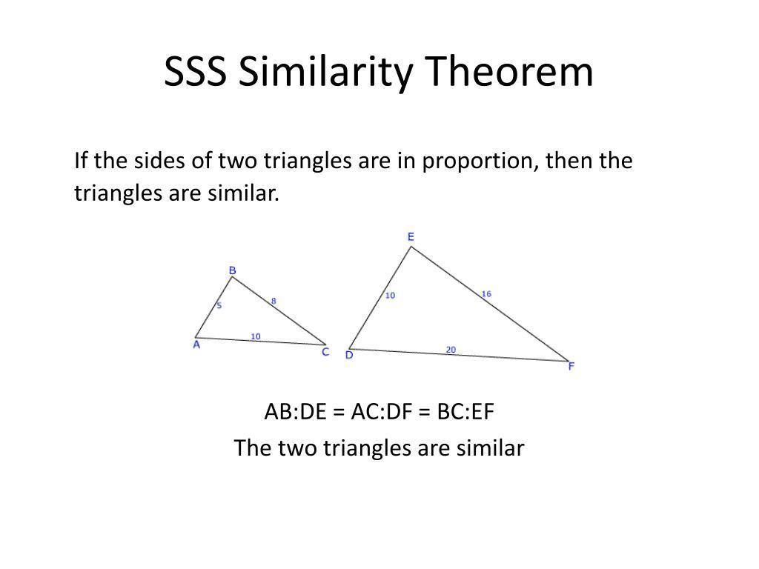
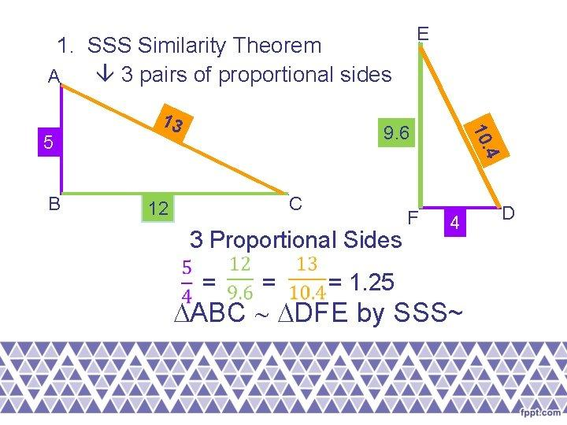
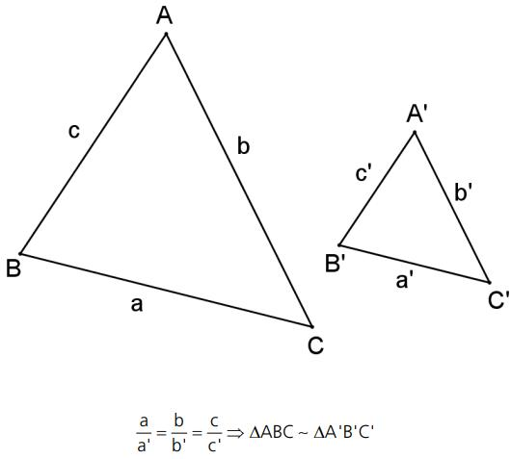

Similarity Criteria Summary
# Source: AI Source: Provided by: [Data Path: Persons Table -> ID Column: 1, Name_En Column: Motasem Essam] -> From: [ChatGPT] on [7/25/2026]
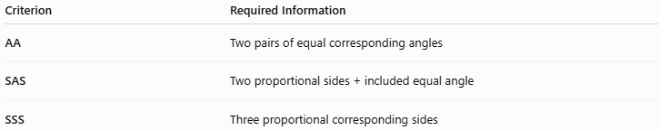
Criterion | Required Information
AA | Two pairs of equal corresponding angles
SAS | Two proportional sides + included equal angle
SSS | Three proportional corresponding sides

Similarity vs Congruence
# Source: AI Source: Provided by: [Data Path: Persons Table -> ID Column: 1, Name_En Column: Motasem Essam] -> From: [ChatGPT] on [7/25/2026]
Similarity and congruence are closely related, but they are not the same.
Congruent Triangles
Same:
- Shape
- Size
$$\boxed{△ABC≅△DEF}$$
Similar Triangles
Same:
- Shape
But size may be different.
$$\boxed{△ABC∼△DEF}$$
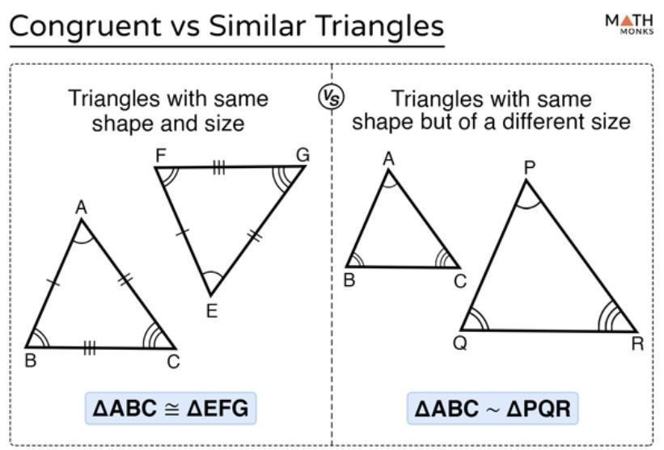
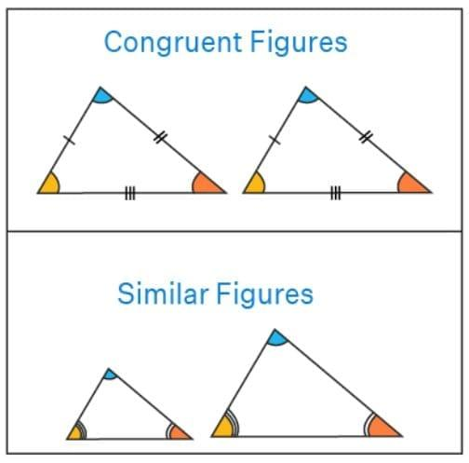
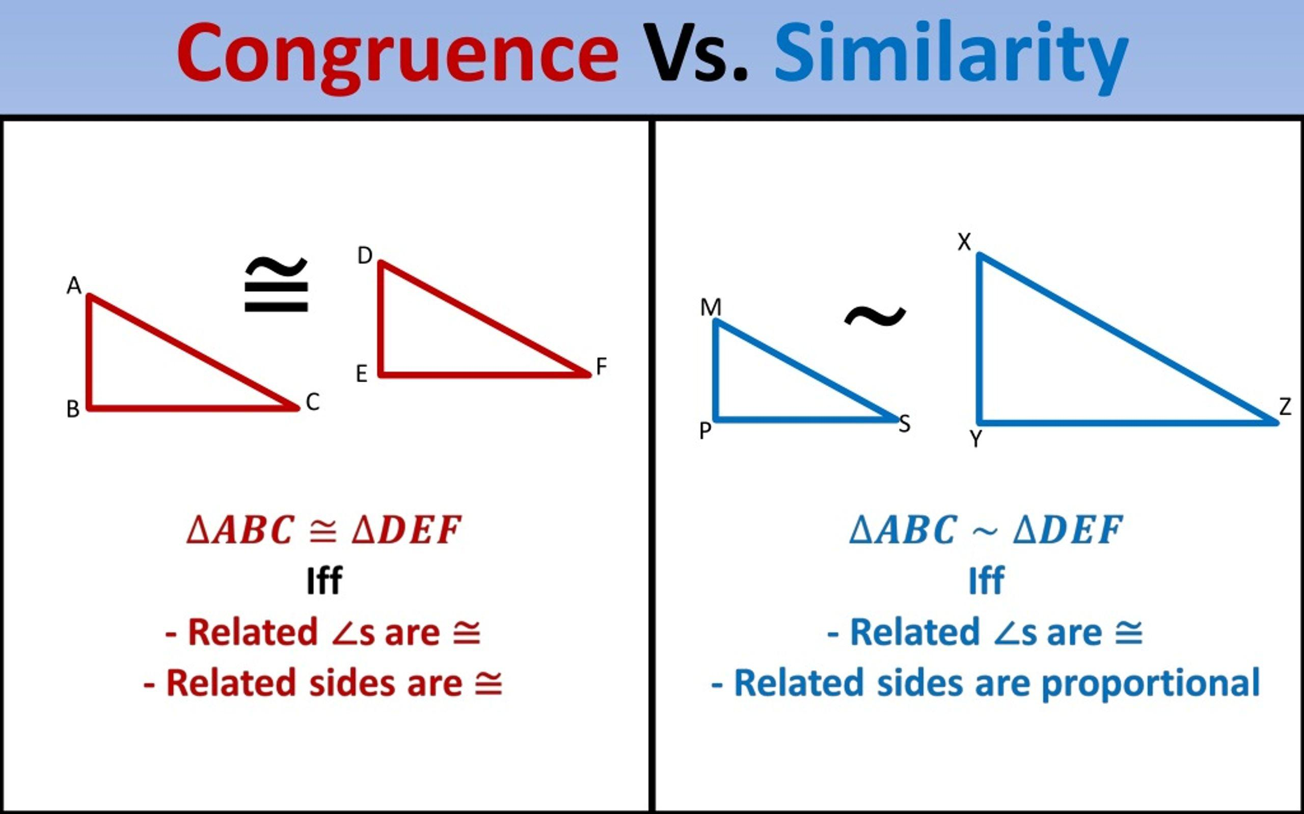

Comparison Table
# Source: AI Source: Provided by: [Data Path: Persons Table -> ID Column: 1, Name_En Column: Motasem Essam] -> From: [ChatGPT] on [7/25/2026]
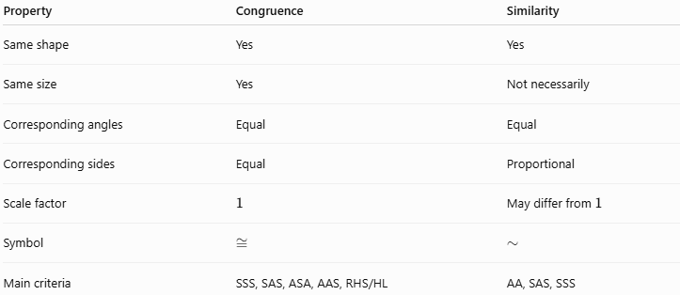
Property | Congruence | Similarity
Same shape | Yes | Yes
Same size | Yes | Not necessarily
Corresponding angles | Equal | Equal
Corresponding sides | Equal | Proportional
Scale factor | $$1$$ | May differ from $1$
Symbol | $$≅$$ | $$∼$$
Main criteria | SSS, SAS, ASA, AAS, RHS/HL | AA, SAS, SSS

Similarity and Side Lengths
# Source: AI Source: Provided by: [Data Path: Persons Table -> ID Column: 1, Name_En Column: Motasem Essam] -> From: [ChatGPT] on [7/25/2026]
If two triangles are similar:
$$\boxed{\frac{a_{1}}{a_{2}}=\frac{b_{1}}{b_{2}}=\frac{c_{1}}{c_{2}}}$$
This common ratio is the scale factor.

Example — Finding an Unknown Side
# Source: AI Source: Provided by: [Data Path: Persons Table -> ID Column: 1, Name_En Column: Motasem Essam] -> From: [ChatGPT] on [7/25/2026]
Suppose:
$$△ABC∼△DEF$$
and:
$$AB=4 \\ DE=8$$
and:
$$BC=5$$
Find $EF$.
Since:
$$\frac{DE}{AB}=2$$
the scale factor is:
$$k=2$$
Therefore:
$$EF=5\left(2\right) \\ \boxed{EF=10}$$

Similarity and Angles
# Source: AI Source: Provided by: [Data Path: Persons Table -> ID Column: 1, Name_En Column: Motasem Essam] -> From: [ChatGPT] on [7/25/2026]
Similar triangles have equal corresponding angles.
If:
$$△ABC∼△DEF$$
then:
$$\boxed{∠A=∠D} \\ \boxed{∠B=∠E} \\ \boxed{∠C=∠F}$$
Therefore, similarity preserves the shape of the triangle.

Similarity and Perimeter
# Source: AI Source: Provided by: [Data Path: Persons Table -> ID Column: 1, Name_En Column: Motasem Essam] -> From: [ChatGPT] on [7/25/2026]
If the scale factor is:
$$k$$
then the perimeters are also related by:
$$\boxed{\frac{P_{2}}{P_{1}}=k}$$
Therefore:
$$\boxed{P_{2}=kP_{1}}$$

Similarity and Area
# Source: AI Source: Provided by: [Data Path: Persons Table -> ID Column: 1, Name_En Column: Motasem Essam] -> From: [ChatGPT] on [7/25/2026]
Area does not scale by $k$.
Instead, area scales by the square of the scale factor:
$$\boxed{\frac{A_{2}}{A_{1}}=k^{2}}$$
Therefore:
$$\boxed{A_{2}=k^{2}A_{1}}$$
Example
If:
$$k=3$$
then the area becomes:
$$3^{2}=9$$
times as large.
So:
$$\boxed{A_{2}=9A_{1}}$$
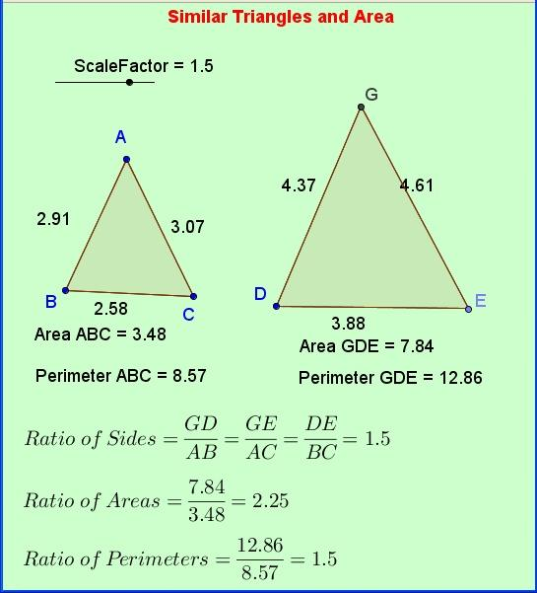
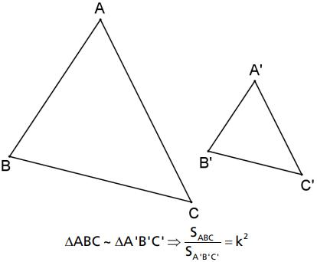
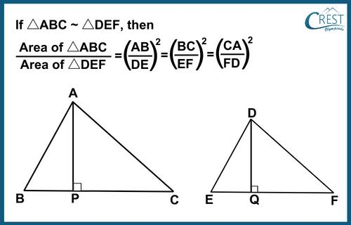
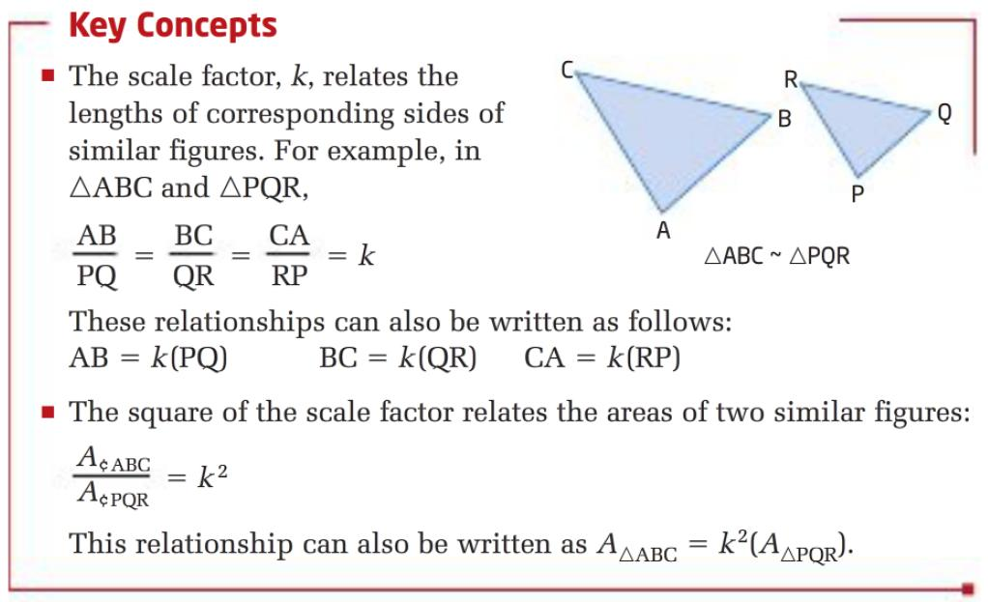
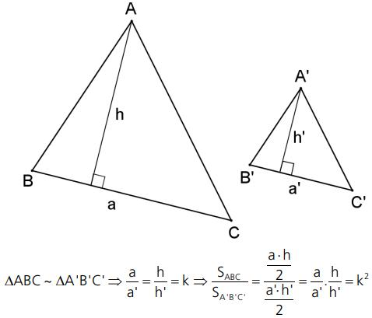

Similarity and Altitudes
# Source: AI Source: Provided by: [Data Path: Persons Table -> ID Column: 1, Name_En Column: Motasem Essam] -> From: [ChatGPT] on [7/25/2026]
Corresponding altitudes of similar triangles are proportional.
If the scale factor is:
$$k$$
then:
$$\boxed{\frac{h_{2}}{h_{1}}=k}$$

Similarity and Medians
# Source: AI Source: Provided by: [Data Path: Persons Table -> ID Column: 1, Name_En Column: Motasem Essam] -> From: [ChatGPT] on [7/25/2026]
Corresponding medians of similar triangles are proportional.
$$\boxed{\frac{m_{2}}{m_{1}}=k}$$
where $k$is the scale factor.

Similarity and Angle Bisectors
# Source: AI Source: Provided by: [Data Path: Persons Table -> ID Column: 1, Name_En Column: Motasem Essam] -> From: [ChatGPT] on [7/25/2026]
Corresponding angle bisectors are also proportional.
$$\boxed{\frac{b_{2}}{b_{1}}=k}$$

Similarity and Perpendicular Bisectors
# Source: AI Source: Provided by: [Data Path: Persons Table -> ID Column: 1, Name_En Column: Motasem Essam] -> From: [ChatGPT] on [7/25/2026]
Corresponding lengths associated with the circumcircles and perpendicular-bisector structure also scale linearly with the scale factor.
For example, circumradii satisfy:
$$\boxed{\frac{R_{2}}{R_{1}}=k}$$

Similarity in Right Triangles
# Source: AI Source: Provided by: [Data Path: Persons Table -> ID Column: 1, Name_En Column: Motasem Essam] -> From: [ChatGPT] on [7/25/2026]
Similar right triangles occur frequently.
For example, two right triangles with the same acute angle are similar by:
$$\boxed{\text{AA}}$$
because:
- Both contain a ${90}^{∘}$angle.
- One additional corresponding angle is equal.
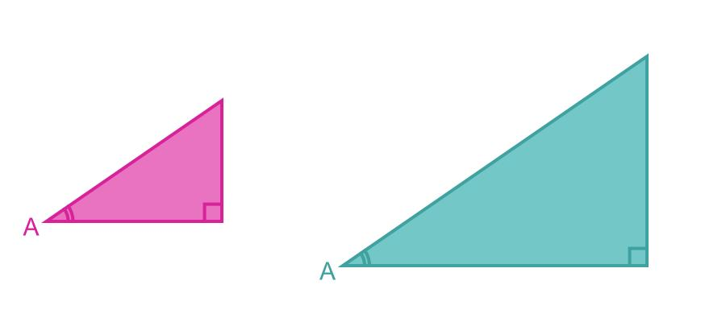
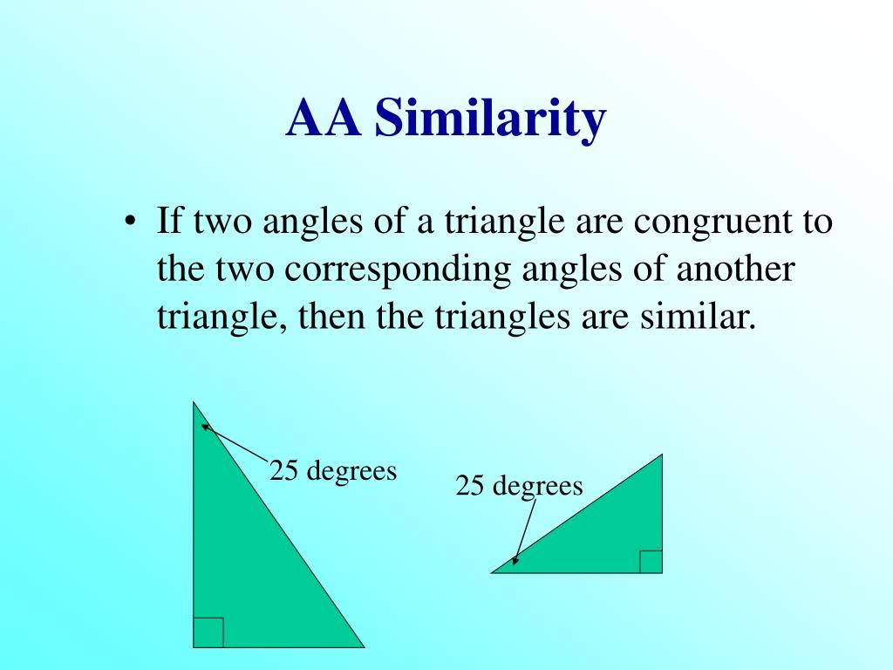
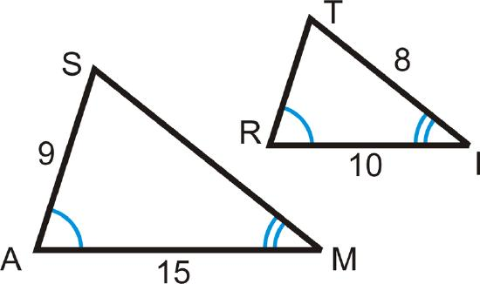
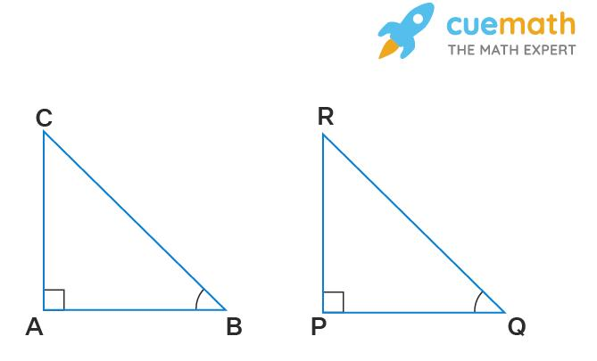

Similarity and Trigonometry
# Source: AI Source: Provided by: [Data Path: Persons Table -> ID Column: 1, Name_En Column: Motasem Essam] -> From: [ChatGPT] on [7/25/2026]
Triangle similarity is one of the foundations of trigonometry.
For a fixed angle, the ratios:
$$\frac{\text{opposite}}{\text{hypotenuse}} \\ \frac{\text{adjacent}}{\text{hypotenuse}}$$
and:
$$\frac{\text{opposite}}{\text{adjacent}}$$
remain constant across similar right triangles.
These ratios lead to:
$$\boxed{\sin{θ}} \\ \boxed{\cos{θ}} \\ \boxed{\tan{θ}}$$
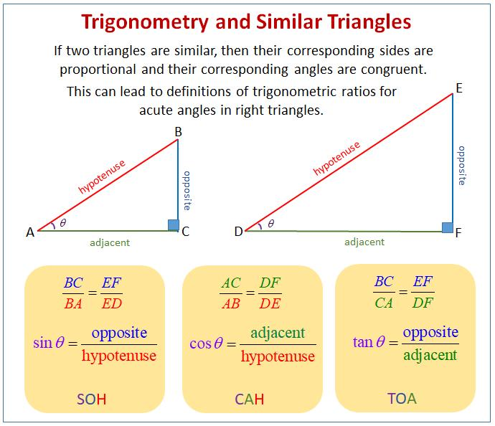
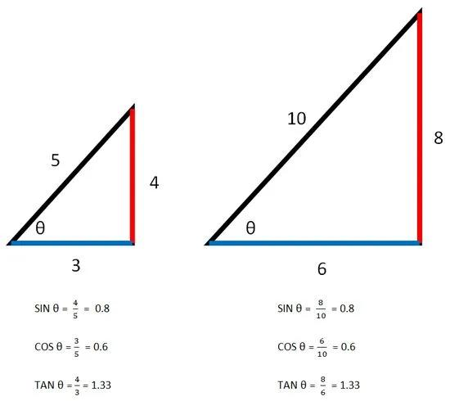
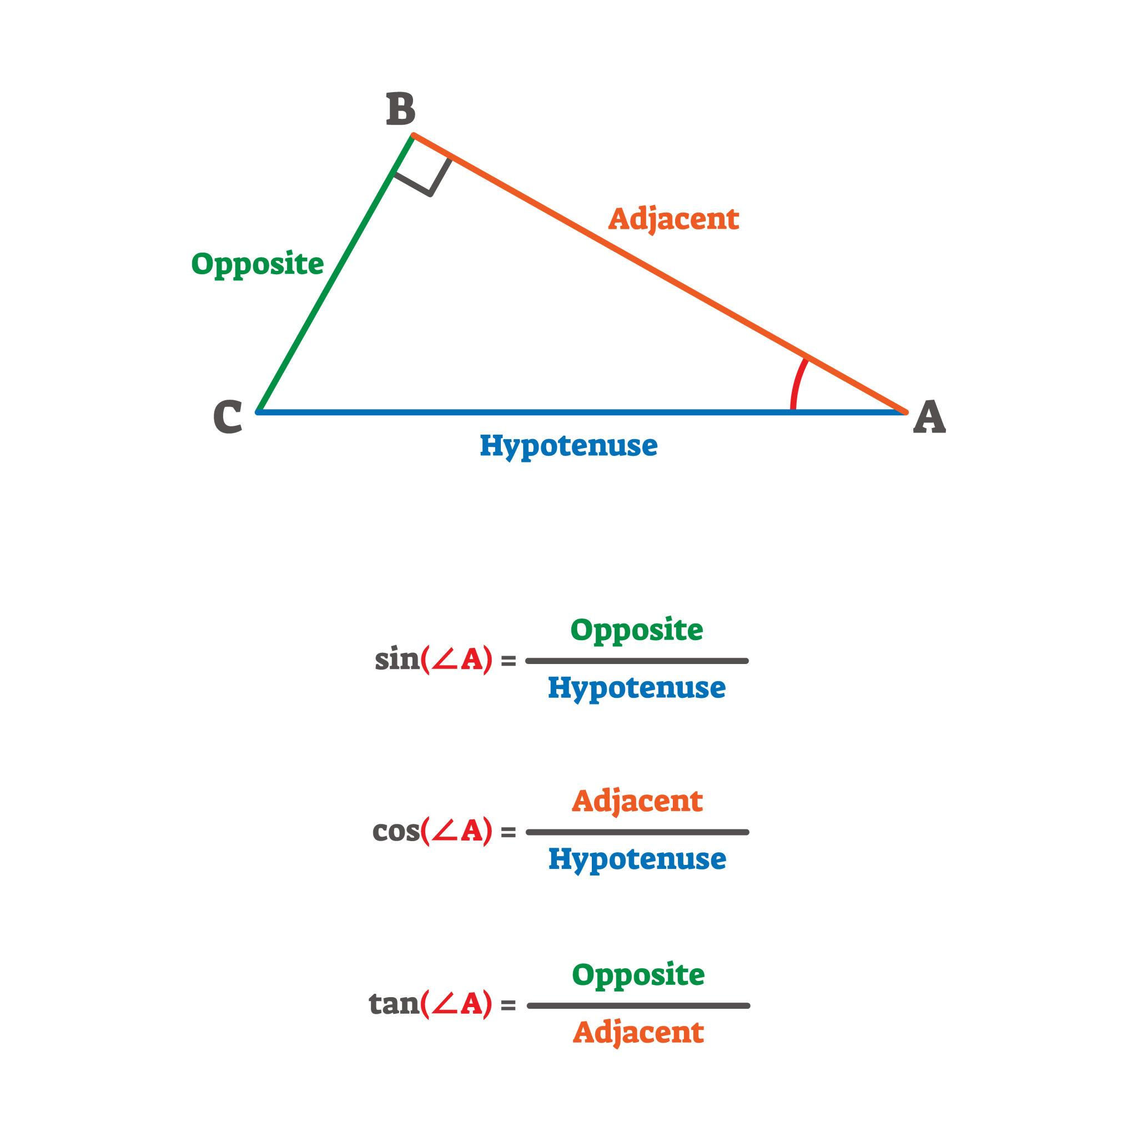
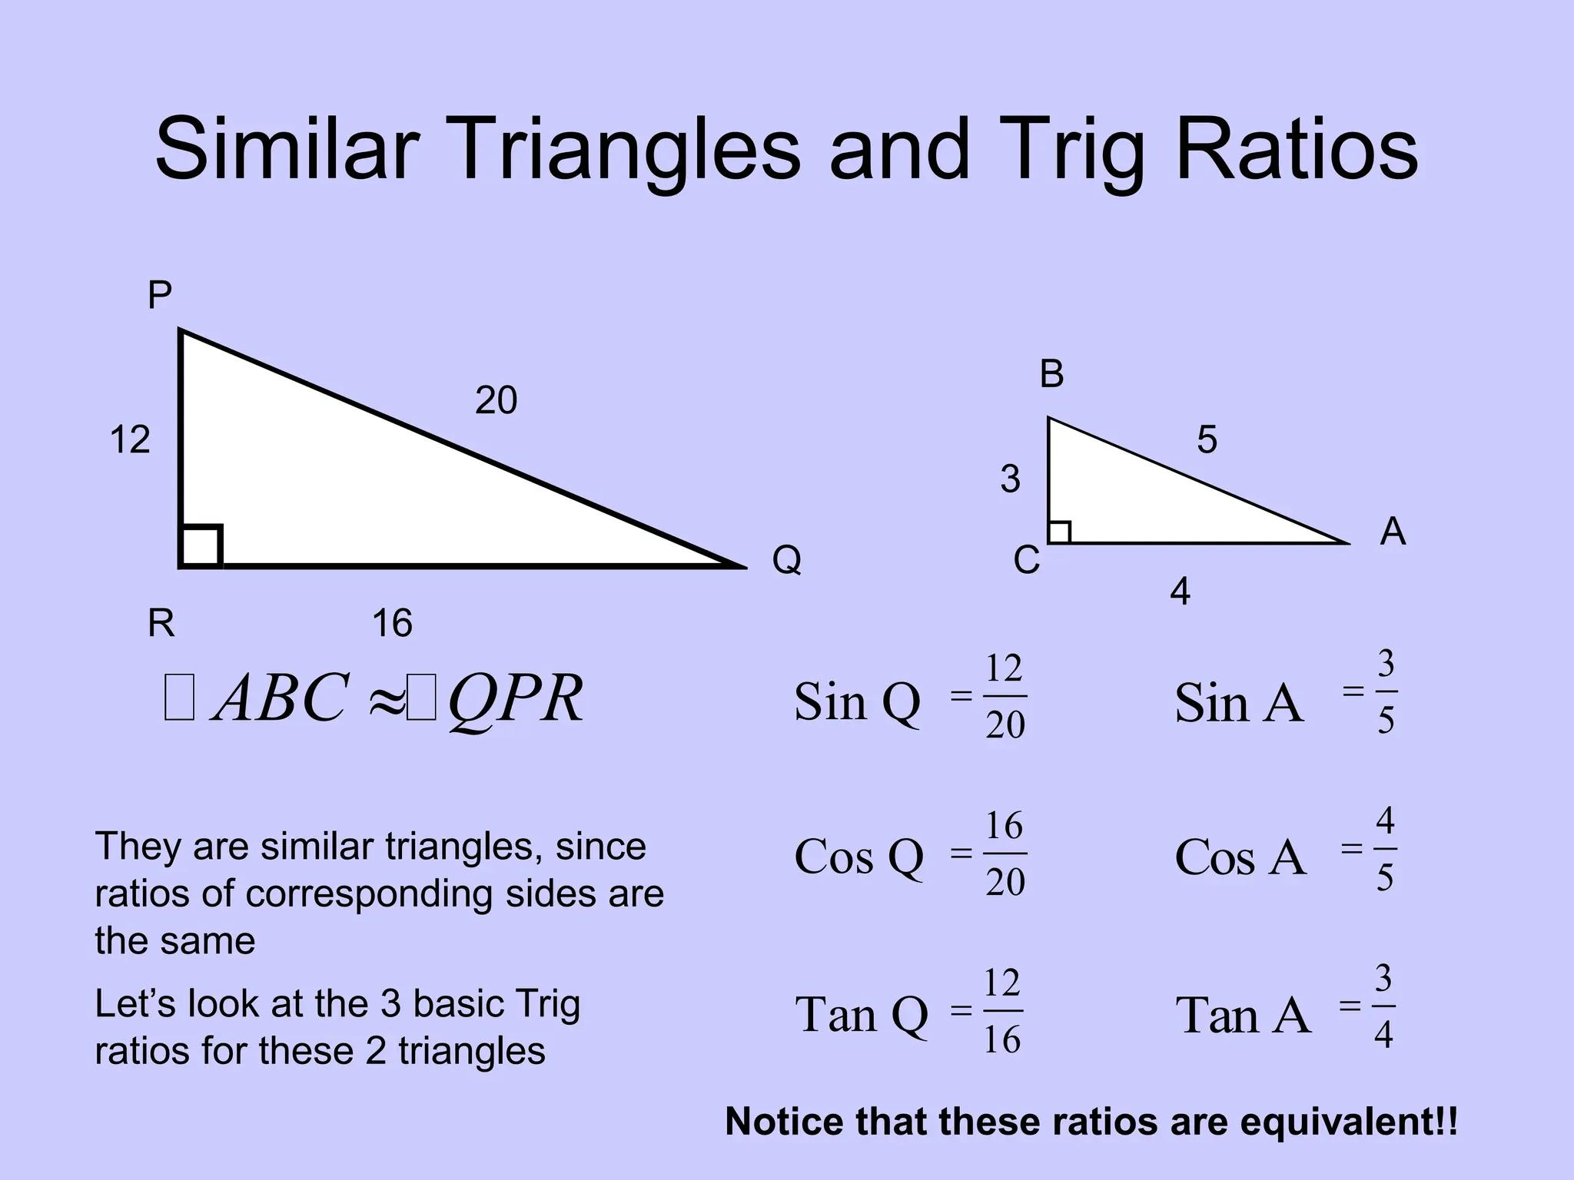

Indirect Measurement
# Source: AI Source: Provided by: [Data Path: Persons Table -> ID Column: 1, Name_En Column: Motasem Essam] -> From: [ChatGPT] on [7/25/2026]
Similarity allows us to measure objects that are difficult to measure directly.
For example, the height of a building can be determined using the shadow of the building and a known object.
If the triangles formed by the objects and their shadows are similar:
$$\frac{\text{building height}}{\text{building shadow}}=\frac{\text{person height}}{\text{person shadow}}$$
Therefore:
$$\boxed{\text{Building Height}=\frac{\text{Building Shadow}×\text{Person Height}}{\text{Person Shadow}}}$$
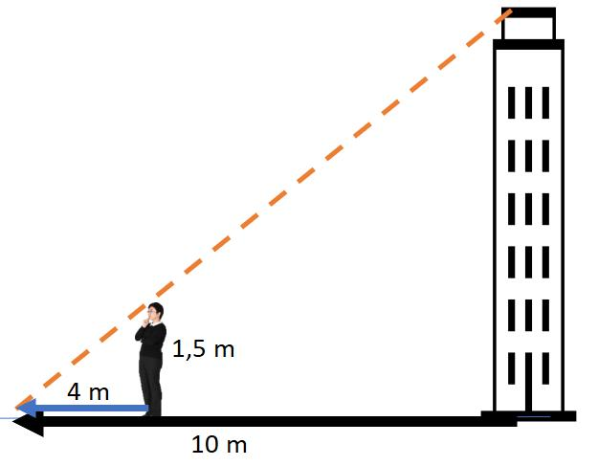
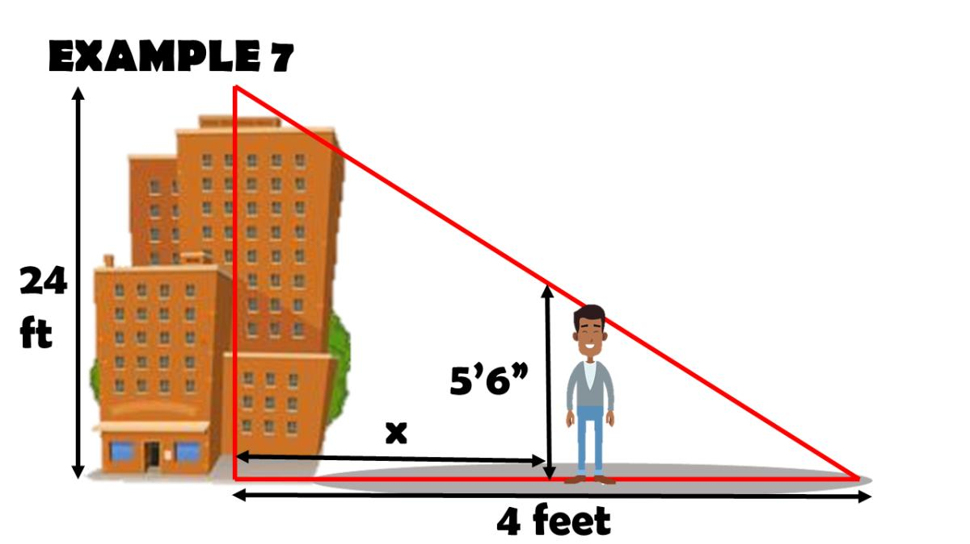
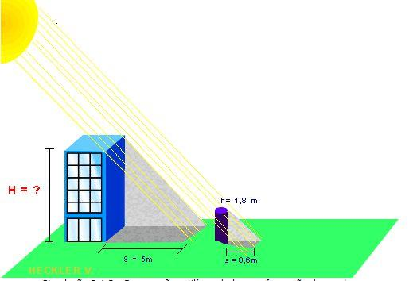
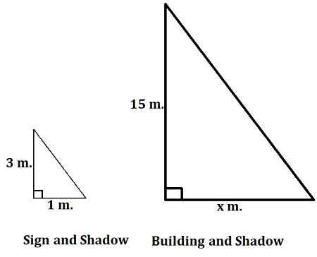
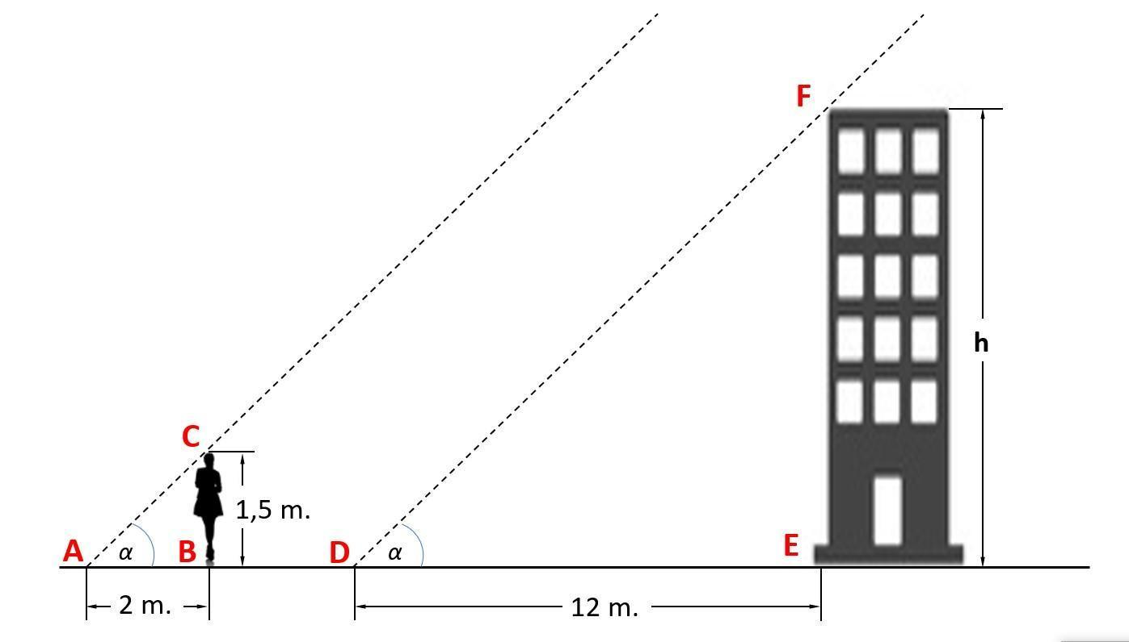

Similarity in Coordinate Geometry
# Source: AI Source: Provided by: [Data Path: Persons Table -> ID Column: 1, Name_En Column: Motasem Essam] -> From: [ChatGPT] on [7/25/2026]
Triangles can be represented using coordinates.
For example:
$$A=\left(x_{1} , y_{1}\right) \\ B=\left(x_{2} , y_{2}\right) \\ C=\left(x_{3} , y_{3}\right)$$
Their side lengths can be calculated using the distance formula:
$$\boxed{d=\sqrt{{\left(x_{2}-x_{1}\right)}^{2}+{\left(y_{2}-y_{1}\right)}^{2}}}$$
The resulting side lengths can then be compared to determine proportionality.

Similarity and Dilation
# Source: AI Source: Provided by: [Data Path: Persons Table -> ID Column: 1, Name_En Column: Motasem Essam] -> From: [ChatGPT] on [7/25/2026]
Dilation is a major transformation associated with similarity.
A dilation changes the size of a figure while preserving its shape and angles.
The coordinate rule for dilation about the origin is:
$$\boxed{\left(x , y\right)→\left(kx , ky\right)}$$
where $k$is the scale factor.
If:
$$k>1$$
the figure becomes larger.
If:
$$0<k<1$$
the figure becomes smaller.
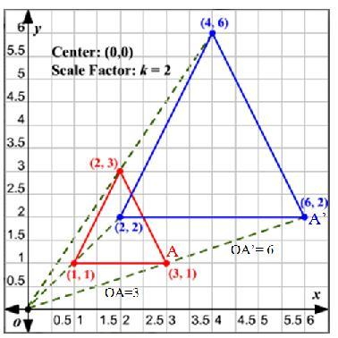
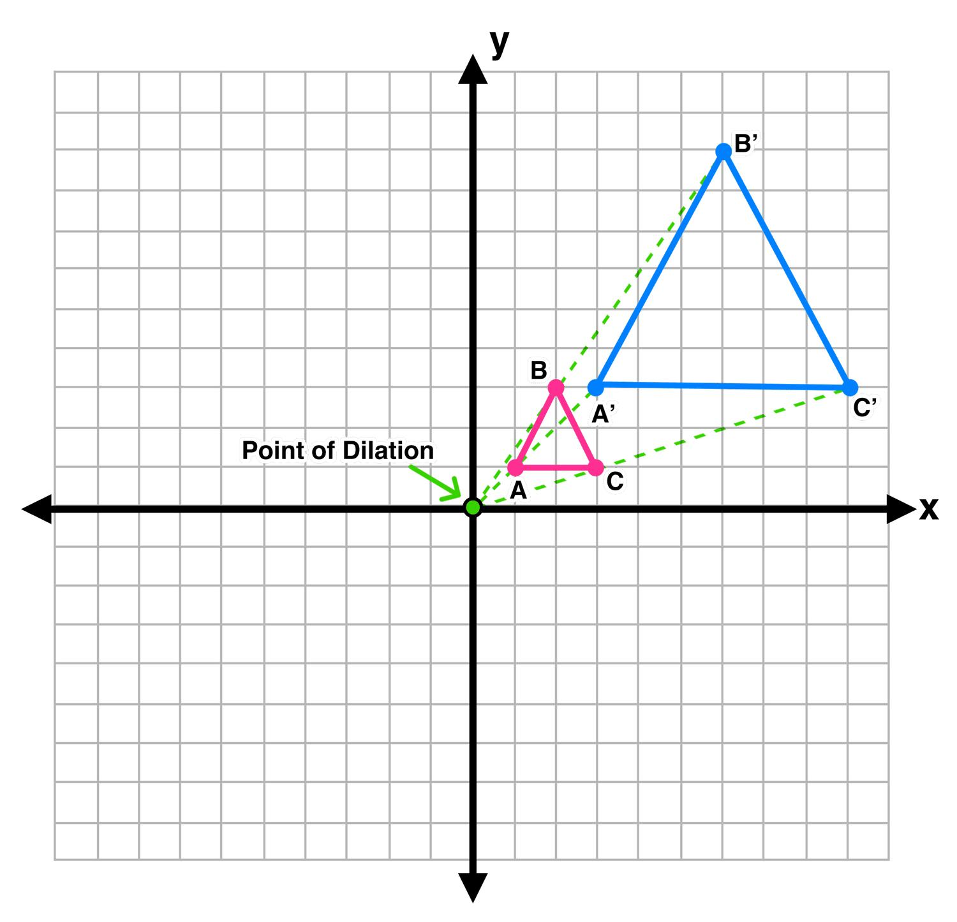
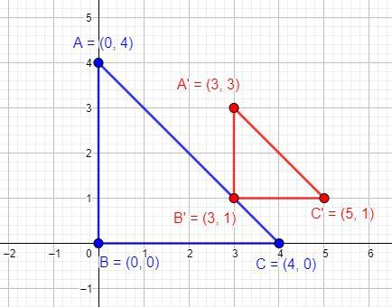
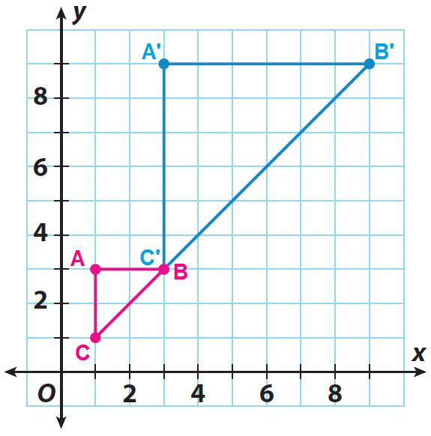
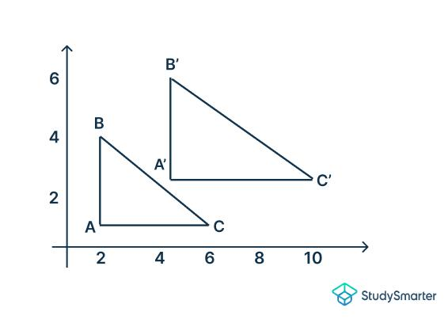

Similarity and Transformations
# Source: AI Source: Provided by: [Data Path: Persons Table -> ID Column: 1, Name_En Column: Motasem Essam] -> From: [ChatGPT] on [7/25/2026]
Triangles can be similar after a combination of:
- Translation
- Rotation
- Reflection
- Dilation
The first three preserve size, while dilation changes size.
A transformation involving a dilation can therefore produce a triangle that is similar but not congruent to the original.

Similarity and Shear
# Source: AI Source: Provided by: [Data Path: Persons Table -> ID Column: 1, Name_En Column: Motasem Essam] -> From: [ChatGPT] on [7/25/2026]
A general shear does not preserve angles or proportional side lengths.
Therefore:
$$\boxed{\text{Shear generally does not preserve similarity}}$$
This is an important difference between shear and dilation.

Example — Proving Similarity by AA
# Source: AI Source: Provided by: [Data Path: Persons Table -> ID Column: 1, Name_En Column: Motasem Essam] -> From: [ChatGPT] on [7/25/2026]
Suppose:
$$∠A={50}^{∘} \\ ∠B={60}^{∘}$$
and another triangle has:
$$∠D={50}^{∘} \\ ∠E={60}^{∘}$$
Then:
$$∠A=∠D$$
and:
$$∠B=∠E$$
Therefore:
$$\boxed{△ABC∼△DEF}$$
by AA.

Example — Proving Similarity by SSS
# Source: AI Source: Provided by: [Data Path: Persons Table -> ID Column: 1, Name_En Column: Motasem Essam] -> From: [ChatGPT] on [7/25/2026]
Suppose triangle 1 has sides:
$$3, 4, 5$$
and triangle 2 has sides:
$$6, 8, 10$$
Compare:
$$\frac{6}{3}=2 \\ \frac{8}{4}=2 \\ \frac{10}{5}=2$$
Since all three ratios are equal:
$$\boxed{△_{1}∼△_{2}}$$
by SSS similarity.

Example — Proving Similarity by SAS
# Source: AI Source: Provided by: [Data Path: Persons Table -> ID Column: 1, Name_En Column: Motasem Essam] -> From: [ChatGPT] on [7/25/2026]
Suppose:
$$AB=4, BC=6$$
and:
$$DE=8, EF=12$$
Then:
$$\frac{DE}{AB}=2$$
and:
$$\frac{EF}{BC}=2$$
Therefore, the corresponding sides are proportional.
If:
$$∠B=∠E$$
then:
$$\boxed{△ABC∼△DEF}$$
by SAS similarity.

Similarity and Congruence Relationship
# Source: AI Source: Provided by: [Data Path: Persons Table -> ID Column: 1, Name_En Column: Motasem Essam] -> From: [ChatGPT] on [7/25/2026]
Every pair of congruent triangles is also similar.
Why?
Because their corresponding sides have ratio:
$$\boxed{1}$$
Therefore:
$$\boxed{\text{Congruent}⇒\text{Similar}}$$
However:
$$\boxed{\text{Similar}⇏\text{Congruent}}$$
because similar triangles can have different sizes.

Real-World Examples
# Source: AI Source: Provided by: [Data Path: Persons Table -> ID Column: 1, Name_En Column: Motasem Essam] -> From: [ChatGPT] on [7/25/2026]
Triangle similarity is used in:
- Measuring building heights.
- Surveying land.
- Mapping.
- Navigation.
- Architecture.
- Engineering.
- Photography.
- Computer graphics.
- Scale models.
- Perspective drawing.
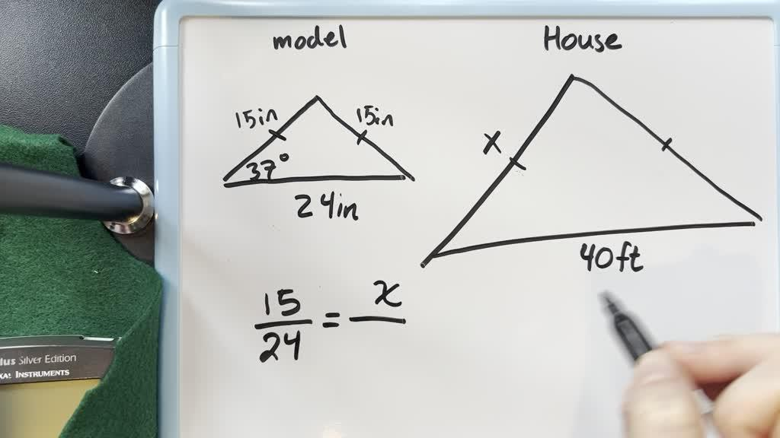
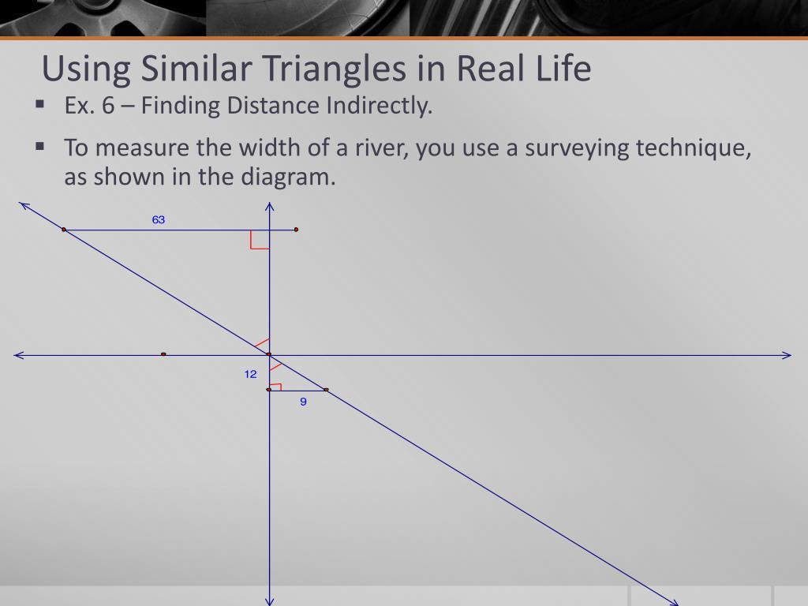
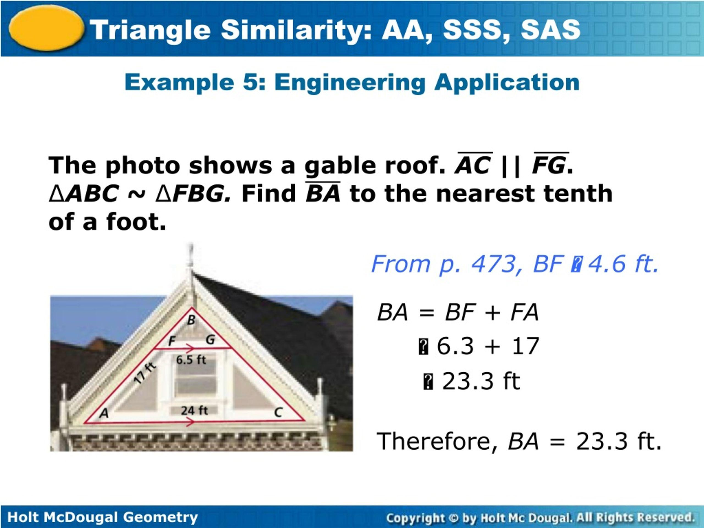
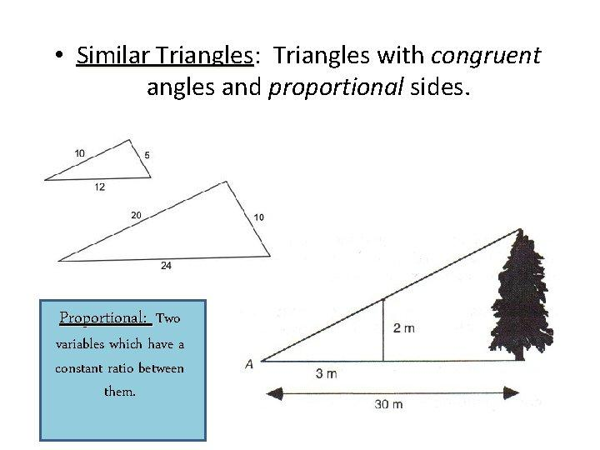
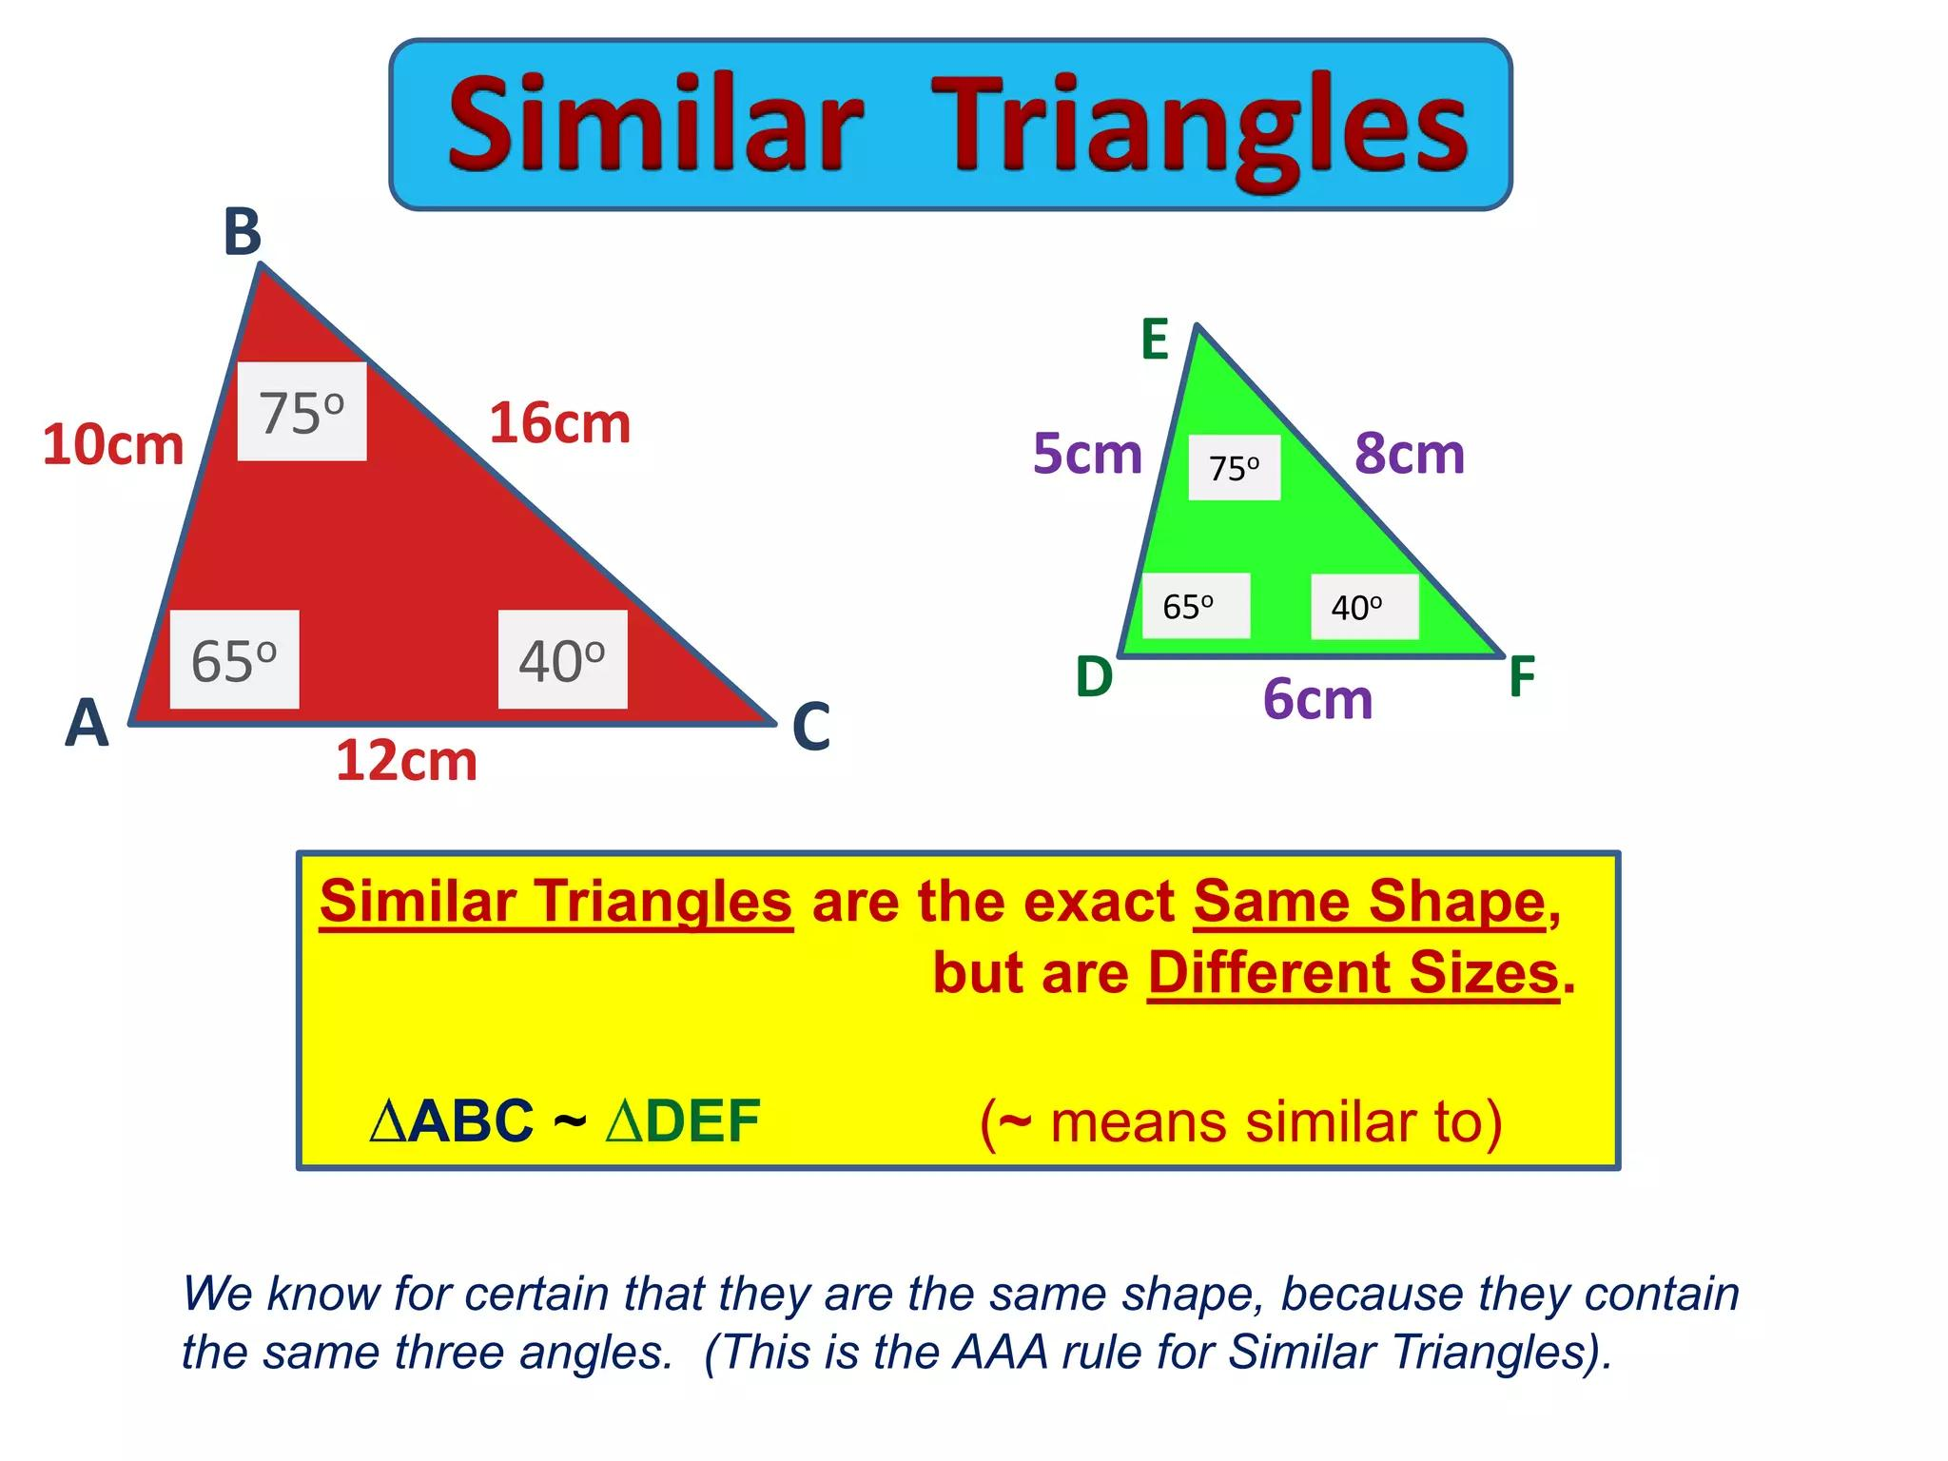

Applications
# Source: AI Source: Provided by: [Data Path: Persons Table -> ID Column: 1, Name_En Column: Motasem Essam] -> From: [ChatGPT] on [7/25/2026]
Triangle similarity is important in:
- Plane Geometry
- Euclidean Geometry
- Trigonometry
- Coordinate Geometry
- Surveying
- Cartography
- Architecture
- Engineering
- Computer Graphics
- CAD
- Navigation

Advantages
# Source: AI Source: Provided by: [Data Path: Persons Table -> ID Column: 1, Name_En Column: Motasem Essam] -> From: [ChatGPT] on [7/25/2026]
Studying triangle similarity helps to:
- Calculate unknown lengths.
- Calculate inaccessible heights.
- Compare geometric figures.
- Understand proportional relationships.
- Develop trigonometric concepts.
- Solve indirect measurement problems.
- Analyze scale models.
- Understand dilation.
- Support engineering and surveying.

Limitations
# Source: AI Source: Provided by: [Data Path: Persons Table -> ID Column: 1, Name_En Column: Motasem Essam] -> From: [ChatGPT] on [7/25/2026]
Triangle similarity:
- Requires sufficient information to establish the relationship.
- Does not mean the triangles have the same size.
- Corresponding vertices must be correctly matched.
- Side lengths must be compared using corresponding sides.
- Equal sides alone do not establish general similarity unless the appropriate criterion is satisfied.
- A shear transformation generally does not preserve similarity.

Comparison with Related Concepts
# Source: AI Source: Provided by: [Data Path: Persons Table -> ID Column: 1, Name_En Column: Motasem Essam] -> From: [ChatGPT] on [7/25/2026]
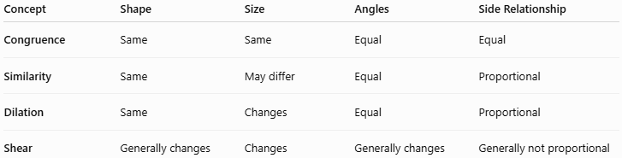
Concept | Shape | Size | Angles | Side Relationship
Congruence | Same | Same | Equal | Equal
Similarity | Same | May differ | Equal | Proportional
Dilation | Same | Changes | Equal | Proportional
Shear | Generally changes | Changes | Generally changes | Generally not proportional

Key Points
# Source: AI Source: Provided by: [Data Path: Persons Table -> ID Column: 1, Name_En Column: Motasem Essam] -> From: [ChatGPT] on [7/25/2026]
- Triangle similarity means two triangles have the same shape but not necessarily the same size.
- The symbol is:
$$\boxed{∼}$$
- Corresponding angles are equal.
- Corresponding sides are proportional:
$$\boxed{\frac{AB}{DE}=\frac{BC}{EF}=\frac{AC}{DF}}$$
- The three main similarity criteria are:
$$\boxed{\text{AA}} \\ \boxed{\text{SAS}} \\ \boxed{\text{SSS}}$$
- The scale factor describes the ratio between corresponding side lengths.
- Perimeters scale by $k$.
- Areas scale by $k^{2}$.
- Congruent triangles are always similar.
- Similar triangles are not necessarily congruent.
- Dilation produces similar figures.
- Triangle similarity is fundamental to trigonometry and indirect measurement.

Conclusion
# Source: AI Source: Provided by: [Data Path: Persons Table -> ID Column: 1, Name_En Column: Motasem Essam] -> From: [ChatGPT] on [7/25/2026]
Triangle Similarity describes a relationship between two triangles that have the same shape but may have different sizes. Their corresponding angles are equal, while their corresponding side lengths are proportional.
The principal methods for proving triangle similarity are:
$$\boxed{\text{AA, SAS, SSS}}$$
If the scale factor between two similar triangles is $k$, corresponding lengths such as sides, heights, medians, and angle bisectors scale by $k$, while areas scale by:
$$\boxed{k^{2}}$$
Triangle similarity is closely connected to dilation, proportionality, trigonometry, coordinate geometry, and indirect measurement. It is widely used in surveying, architecture, engineering, navigation, mapping, CAD, and computer graphics, making it one of the most important geometric relationships in plane geometry.

